**CPK 3 GRK**

1. **Bangunan 2D interaksi keyboard**

void timer(int value){

glutPostRedisplay();

glutTimerFunc(10,timer,0);

}

int main (int argc, char **argv){

glutInit(&argc,argv);

glutInitWindowPosition(100,100);

glutInitWindowSize(400,400);

glutCreateWindow("Agung Gumilang");

gluOrtho2D(-50,50,-50,50);

glutDisplayFunc(display);

glutTimerFunc(1, timer,0);

glutMainLoop();

}

void myKeyboard(unsigned char key, int x, int y){

switch(key){

case 'j':

a=4;

break;

case 'l':

a=-4;

break;

case 'h':

glColor3f(0,1,0);

break;

case 'k':

glColor3f(1,1,0);

break;

}

}

void display(void){

glClear(GL_COLOR_BUFFER_BIT);

glutKeyboardFunc(myKeyboard);

glRotatef(a,0,0,1);

Segiga();

glFlush();

}

#include "stdlib.h"

#include "GL/glut.h"

int a = 0;

void Segiga(){

glBegin(GL_TRIANGLES);

glVertex2f(0.,0.);

glVertex2f(10.,30.);

glVertex2f(-10.,30.);

glVertex2f(0.,0.);

glVertex2f(-10.,-30.);

glVertex2f(10.,-30.);

glVertex2f(0.,0.);

glVertex2f(30.,10.);

glVertex2f(30.,-10.);

glVertex2f(0.,0.);

glVertex2f(-30.,10.);

glVertex2f(-30.,-10.);

glEnd();

}

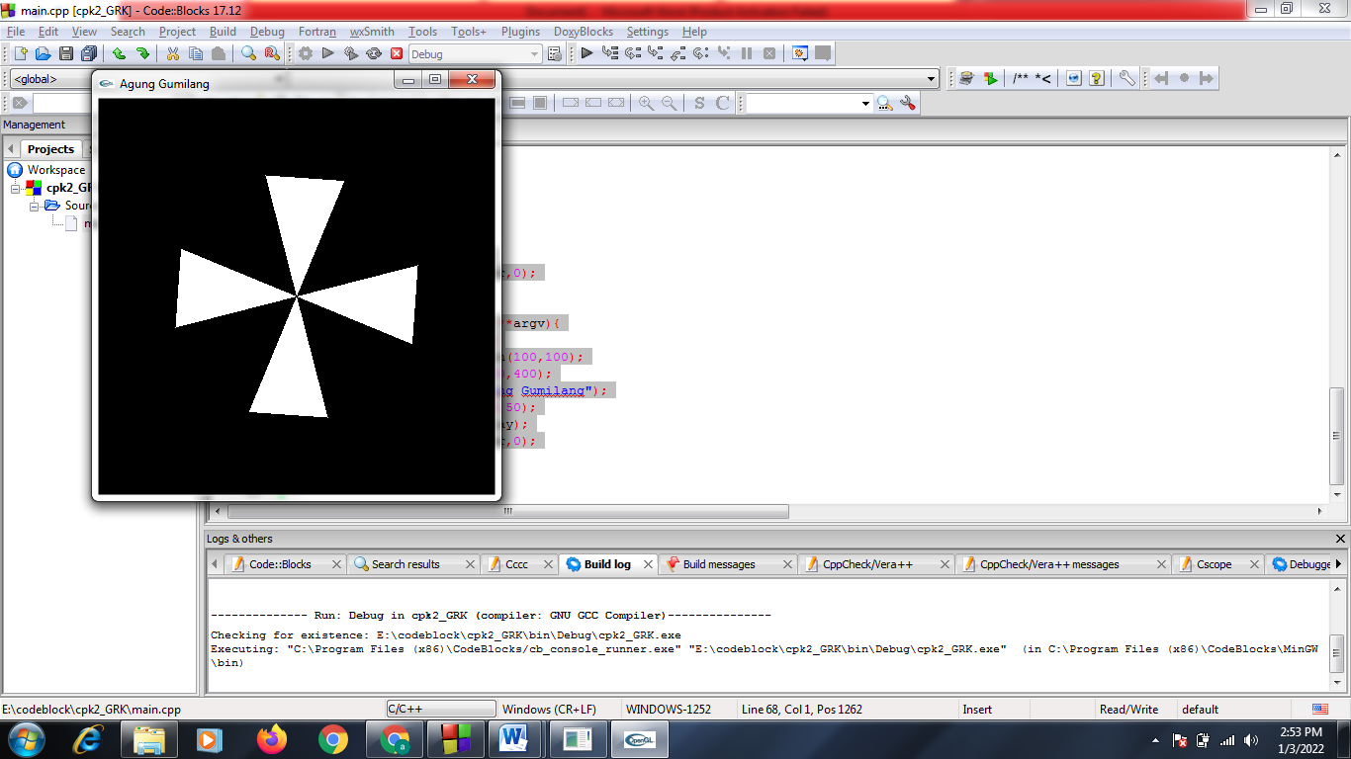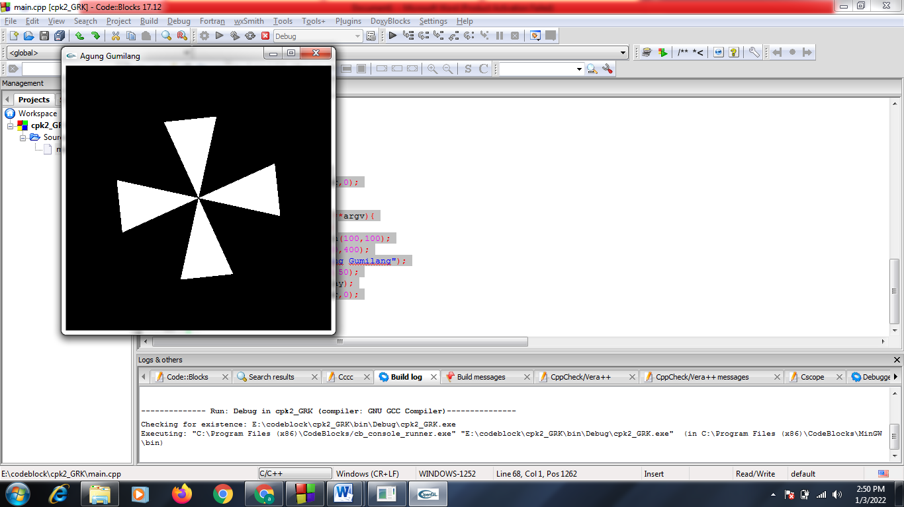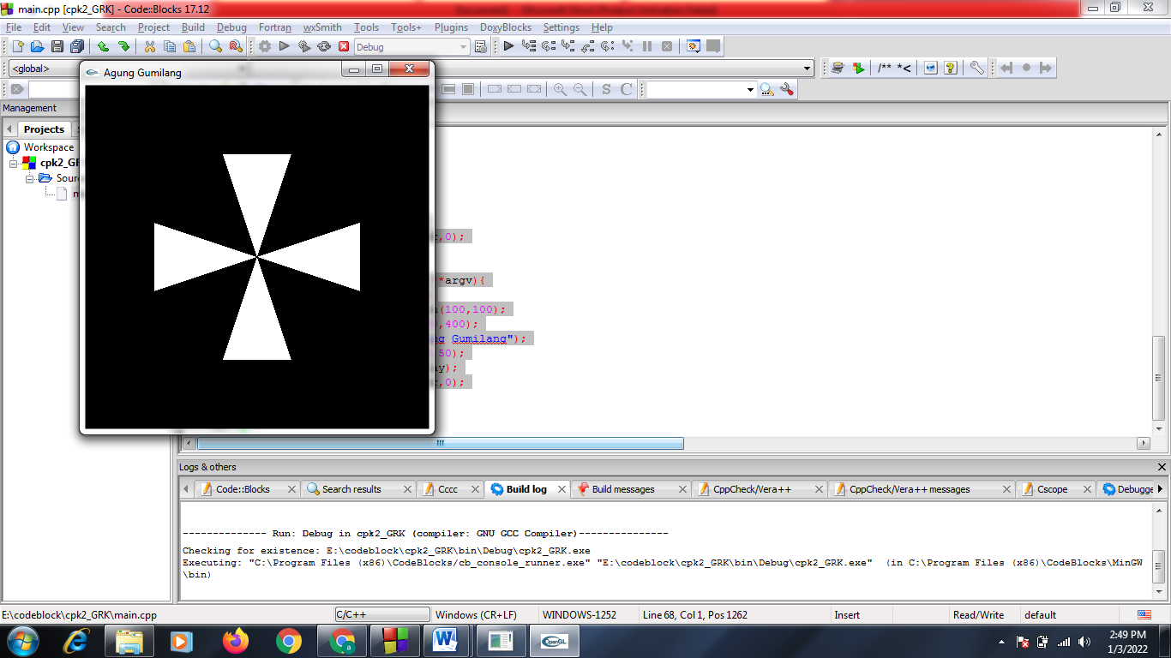**Hasil Run**

Tampilan Awal

Ketika menekan tombol “l” maka akan berputar searah jarum jam

Ketika menekan tombol “j” maka akan berputar berlawanan jarum jam

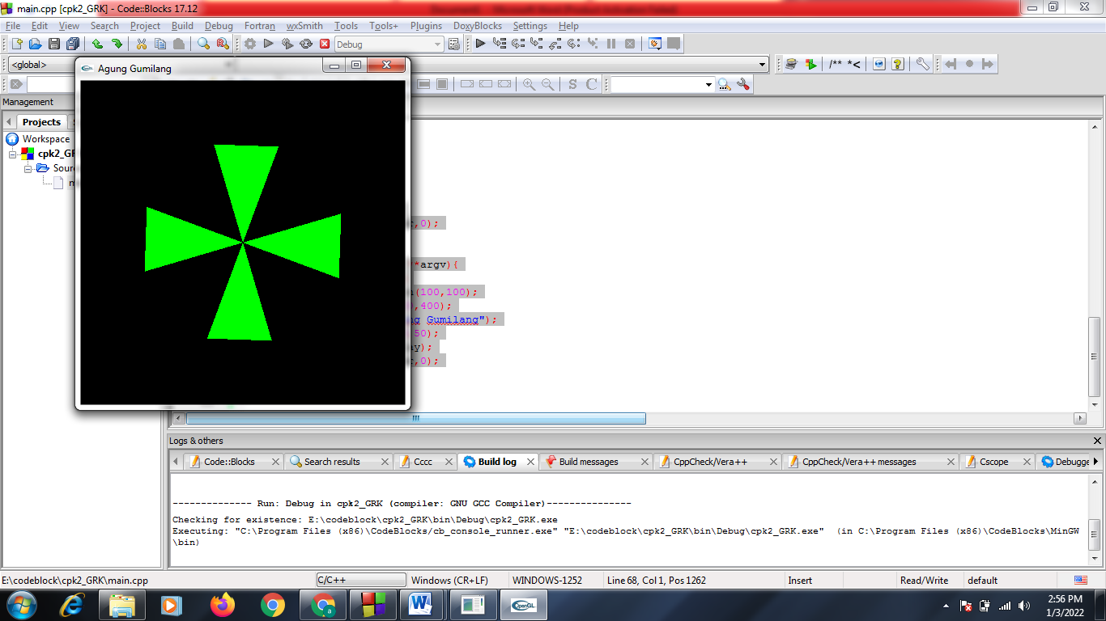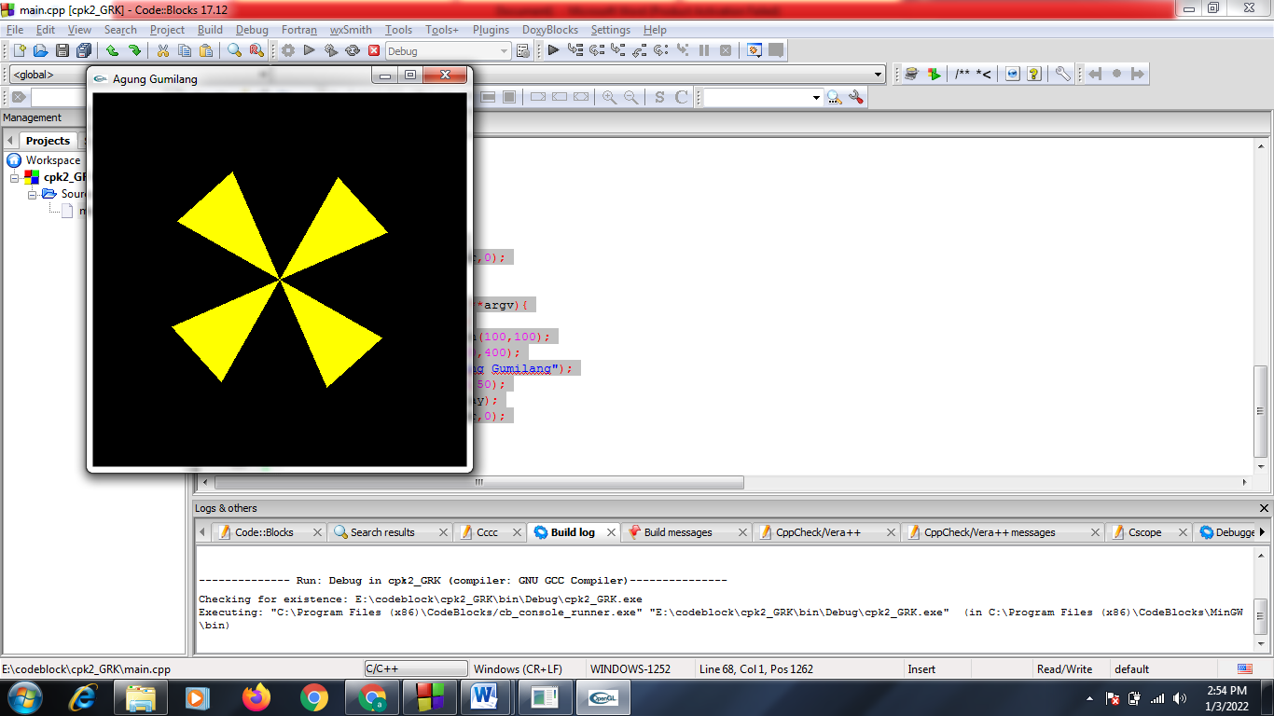

Jika kita menekan tombol “k” maka warna yang semula putih menjadi berwarna kuning

Jika kita menekan tombol “h” maka warna yang semula putih menjadi berwarna hijau

1. **Bangun 2D interaksi mouse**

void renderScene(void){

glClear(GL_COLOR_BUFFER_BIT);

glClearColor(1,1,1,1);

glPushMatrix();

glTranslatef(x,y,z);

drawQuad();

glPopMatrix();

glFlush();

}

void timer(int value){

glutPostRedisplay();

glutTimerFunc(50,timer,0);

}

void main (int argc, char **argv){

glutInit(&argc, argv);

glutInitWindowPosition(100,100);

glutInitWindowSize(w,h);

glutCreateWindow("Interaksi Mouse");

gluOrtho2D(-w/2,w/2,-h/2,h/2);

glutDisplayFunc(renderScene);

glutMouseFunc(mouse);

glutTimerFunc(1,timer,0);

glutMainLoop();

}

#include "stdlib.h"

#include "stdio.h"

#include "gl/glut.h"

int x=0,y=0,z=0;

int w=480, h=480;

void drawQuad() {

glBegin(GL_POLYGON);

glColor3f(0,0,1);

glVertex2f(-20.,-20.);

glVertex2f(20.,-20.);

glVertex2f(20.,20.);

glVertex2f(-20.,20.);

glEnd();

}

void mouse(int button, int state, int xmouse, int ymouse){

if(button==GLUT_LEFT_BUTTON && state==GLUT_DOWN){

x = xmouse-(w/2);

y = (h/2)-ymouse;

printf(" x = %d y = %d",x,y);

}

}

**Hasil Run**

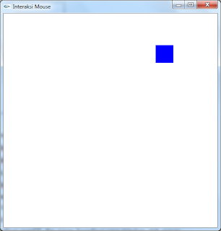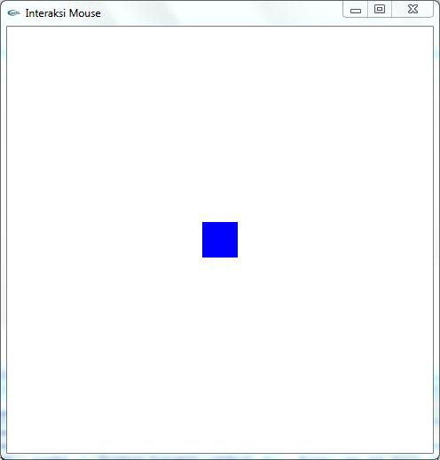

Setelah mouse di klik di posisi yang berbeda

Tampilan Awal

1. **Bangun 3D interaksi mouse & keyboard**

|  |  |
| --- | --- |
|  | #include<GL/gl.h> |
|  | #include<GL/glu.h> |
|  | #include<GL/glut.h> |
|  | //deklarasi fungsi |
|  | void display(); |
|  | void init(); |
|  | void reshape(int, int); |
|  | void keyboard(unsigned char, int, int); //+1 |
|  | //main program |
|  | int main (int argc, char** argv){ |
|  | //inisialisasi |
|  | glutInit(&argc, argv); |
|  | glutInitDisplayMode( GLUT_DOUBLE | GLUT_DEPTH ); //+2 GLUT_DEPTH : mengalokasikan sumbu z |
|  | glutInitWindowPosition(400, 300); //atur sumbu x dan y |
|  | glutInitWindowSize(800, 800); //atur lebar dan tinggi jendela |
|  | glutCreateWindow("UAS GRAFIKA INTERIOR KAMAR"); |
|  | glutDisplayFunc(display); //memanggil fungsi display |
|  | glutReshapeFunc(reshape); //memanggil fungsi reshape |
|  | glutKeyboardFunc(keyboard); // +3 memanggil fungsi keyboard |
|  | init(); |
|  | glutMainLoop(); //looping program utama |
|  | } |
|  | void init(){ |
|  | glEnable(GL_DEPTH_TEST); //+4 |
|  | glClearColor(0.0, 0.0, 0.0, 1.0); |
|  | } |
|  | void display(){ |
|  | //reset |
|  | glClear(GL_COLOR_BUFFER_BIT | GL_DEPTH_BUFFER_BIT); //+5 |
|  |  |
|  |  |
|  |  |
|  | //DINDING DEPAN |
|  | glBegin(GL_QUADS); //+5 |
|  | glColor3ub(119, 128, 121); |
|  | glVertex3f(-30.0, 50.0, 3.0); |
|  | glVertex3f(-30.0, -30.0, 3.0); |
|  | glVertex3f(30.0, -30.0, 3.0); |
|  | glVertex3f(30.0, 50.0, 3.0); |
|  | glEnd(); |
|  |  |
|  |  |
|  |  |
|  | //AC BELAKANG |
|  | glBegin(GL_QUADS); //+5 |
|  | glColor3f(1.0, 1.0, 1.0); |
|  | glVertex3f(20.0, 45.0, 4.0); |
|  | glVertex3f(20.0, 40.0, 4.0); |
|  | glVertex3f(5.0, 40.0, 4.0); |
|  | glVertex3f(5.0, 45.0, 4.0); |
|  | glEnd(); |
|  |  |
|  | //AC DEPAN |
|  | glBegin(GL_QUADS); //+5 |
|  | glColor3ub(255, 255, 255); |
|  | glVertex3f(20.0, 45.0, 6.0); |
|  | glVertex3f(20.0, 40.0, 6.0); |
|  | glVertex3f(5.0, 40.0, 6.0); |
|  | glVertex3f(5.0, 45.0, 6.0); |
|  | glEnd(); |
|  |  |
|  | //AC GARIS DEPAN |
|  | glBegin(GL_QUADS); //+5 |
|  | glColor3ub(0, 0, 0); |
|  | glVertex3f(20.0, 42.0, 6.1); |
|  | glVertex3f(20.0, 41.5, 6.1); |
|  | glVertex3f(5.0, 41.5, 6.1); |
|  | glVertex3f(5.0, 42.0, 6.1); |
|  | glEnd(); |
|  |  |
|  | //AC KIRI |
|  | glBegin(GL_QUADS); //+5 |
|  | glColor3ub(255, 255, 255); |
|  | glVertex3f(5.0, 40.0, 4.0); |
|  | glVertex3f(5.0, 45.0, 4.0); |
|  | glVertex3f(5.0, 45.0, 6.0); |
|  | glVertex3f(5.0, 40.0, 6.0); |
|  | glEnd(); |
|  |  |
|  | //AC KANAN |
|  | glBegin(GL_QUADS); //+5 |
|  | glColor3ub(255, 255, 255); |
|  | glVertex3f(20.0, 40.0, 4.0); |
|  | glVertex3f(20.0, 45.0, 4.0); |
|  | glVertex3f(20.0, 45.0, 6.0); |
|  | glVertex3f(20.0, 40.0, 6.0); |
|  | glEnd(); |
|  |  |
|  |  |
|  |  |
|  | //BINGKAI BELAKANG |
|  | glBegin(GL_QUADS); //+5 |
|  | glColor3ub(28, 52, 97); |
|  | glVertex3f(-20.0, 30.0, 4.0); |
|  | glVertex3f(-20.0, 15.0, 4.0); |
|  | glVertex3f(-5.0, 15.0, 4.0); |
|  | glVertex3f(-5.0, 30.0, 4.0); |
|  | glEnd(); |
|  |  |
|  | //BINGKAI DEPAN |
|  | glBegin(GL_QUADS); //+5 |
|  | glColor3ub(255, 255, 255); |
|  | glVertex3f(-20.0, 30.0, 6.0); |
|  | glVertex3f(-20.0, 15.0, 6.0); |
|  | glVertex3f(-5.0, 15.0, 6.0); |
|  | glVertex3f(-5.0, 30.0, 6.0); |
|  | glEnd(); |
|  |  |
|  | //BINGKAI TUTUP ATAS |
|  | glBegin(GL_QUADS); //+5 |
|  | glColor3ub(28, 52, 97); |
|  | glVertex3f(-20.0, 30.0, 4.0); |
|  | glVertex3f(-5.0, 30.0, 4.0); |
|  | glVertex3f(-5.0, 30.0, 6.0); |
|  | glVertex3f(-20.0, 30.0, 6.0); |
|  | glEnd(); |
|  |  |
|  | //BINGKAI TUTUP BAWAH |
|  | glBegin(GL_QUADS); //+5 |
|  | glColor3ub(28, 52, 97); |
|  | glVertex3f(-20.0, 15.0, 4.0); |
|  | glVertex3f(-5.0, 15.0, 4.0); |
|  | glVertex3f(-5.0, 15.0, 6.0); |
|  | glVertex3f(-20.0, 15.0, 6.0); |
|  | glEnd(); |
|  |  |
|  | //BINGKAI TUTUP ATAS |
|  | glBegin(GL_QUADS); //+5 |
|  | glColor3ub(28, 52, 97); |
|  | glVertex3f(-5.0, 30.0, 4.0); |
|  | glVertex3f(-5.0, 15.0, 4.0); |
|  | glVertex3f(-5.0, 15.0, 6.0); |
|  | glVertex3f(-5.0, 30.0, 6.0); |
|  | glEnd(); |
|  |  |
|  | //BINGKAI TUTUP KANAN |
|  | glBegin(GL_QUADS); //+5 |
|  | glColor3ub(28, 52, 97); |
|  | glVertex3f(-20.0, 30.0, 4.0); |
|  | glVertex3f(-20.0, 15.0, 4.0); |
|  | glVertex3f(-20.0, 15.0, 6.0); |
|  | glVertex3f(-20.0, 30.0, 6.0); |
|  | glEnd(); |
|  |  |
|  |  |
|  |  |
|  | //DINDING BELAKANG |
|  | glBegin(GL_QUADS); //+5 |
|  | glColor3ub(53,56,54); |
|  | glVertex3f(-30.0, 50.0, -3.0); |
|  | glVertex3f(-30.0, -30.0, -3.0); |
|  | glVertex3f(30.0, -30.0, -3.0); |
|  | glVertex3f(30.0, 50.0, -3.0); |
|  | glEnd(); |
|  |  |
|  | //DINDING ATAS |
|  | glBegin(GL_QUADS); //+5 |
|  | glColor3ub(53,56,54); |
|  | glVertex3f(-30.0, 50.0, -3.0); |
|  | glVertex3f(-30.0, 50.0, 3.0); |
|  | glVertex3f(30.0, 50.0, 3.0); |
|  | glVertex3f(30.0, 50.0, -3.0); |
|  | glEnd(); |
|  |  |
|  | //DINDING BAWAH |
|  | glBegin(GL_QUADS); //+5 |
|  | glColor3ub(53,56,54); |
|  | glVertex3f(-30.0, -30.0, -3.0); |
|  | glVertex3f(-30.0, -30.0, 3.0); |
|  | glVertex3f(30.0, -30.0, 3.0); |
|  | glVertex3f(30.0, -30.0, -3.0); |
|  | glEnd(); |
|  |  |
|  | //DINDING KANAN |
|  | glBegin(GL_QUADS); //+5 |
|  | glColor3ub(66,66,245); |
|  | glVertex3f(30.0, 50.0, 3.0); |
|  | glVertex3f(30.0, -30.0, 3.0); |
|  | glVertex3f(30.0, -30.0, -3.0); |
|  | glVertex3f(30.0, 50.0, -3.0); |
|  | glEnd(); |
|  |  |
|  | //DINDING KIRI |
|  | glBegin(GL_QUADS); //+5 |
|  | glColor3f(1.0, 0.0, 0.0); |
|  | glVertex3f(-30.0, 50.0, -3.0); |
|  | glVertex3f(-30.0, -30.0, -3.0); |
|  | glVertex3f(-30.0, -30.0, 3.0); |
|  | glVertex3f(-30.0, 50.0, 3.0); |
|  | glEnd(); |
|  |  |
|  |  |
|  |  |
|  | //DINDING KIRI |
|  | //DEPAN |
|  | glBegin(GL_QUADS); //+5 |
|  | glColor3ub(53,56,54); |
|  | glVertex3f(-30.0, 50.0, 60.0); |
|  | glVertex3f(-30.0, -30.0, 60.0); |
|  | glVertex3f(-27.0, -30.0, 60.0); |
|  | glVertex3f(-27.0, 50.0, 60.0); |
|  | glEnd(); |
|  |  |
|  | //DINDING TUTUP ATAS |
|  | glBegin(GL_QUADS); //+5 |
|  | glColor3ub(53,56,54); |
|  | glVertex3f(-30.0, 50.0, 60.0); |
|  | glVertex3f(-27.0, 50.0, 60.0); |
|  | glVertex3f(-27.0, 50.0, 3.0); |
|  | glVertex3f(-30.0, 50.0, 3.0); |
|  | glEnd(); |
|  |  |
|  | //DINDING BELAKANG |
|  | glBegin(GL_QUADS); //+5 |
|  | glColor3ub(53,56,54); |
|  | glVertex3f(-30.0, 50.0, 3.0); |
|  | glVertex3f(-30.0, -30.0, 3.0); |
|  | glVertex3f(-27.0, -30.0, 3.0); |
|  | glVertex3f(-27.0, 50.0, 3.0); |
|  | glEnd(); |
|  |  |
|  | // DINDING KIRI |
|  | glBegin(GL_QUADS); //+5 |
|  | glColor3ub(53,56,54); |
|  | glVertex3f(-30.0, 50.0, 60.0); |
|  | glVertex3f(-30.0, -30.0, 60.0); |
|  | glVertex3f(-30.0, -30.0, 3.0); |
|  | glVertex3f(-30.0, 50.0, 3.0); |
|  | glEnd(); |
|  |  |
|  | //DINDING KANAN |
|  | glBegin(GL_QUADS); //+5 |
|  | glColor3ub(119, 128, 121); |
|  | glVertex3f(-27.0, 50.0, 60.0); |
|  | glVertex3f(-27.0, -30.0, 60.0); |
|  | glVertex3f(-27.0, -30.0, 3.0); |
|  | glVertex3f(-27.0, 50.0, 3.0); |
|  | glEnd(); |
|  |  |
|  |  |
|  |  |
|  | //VENTILASI KIRI |
|  | glBegin(GL_QUADS); //+5 |
|  | glColor3ub(0.0,0.0,0.0); |
|  | glVertex3f(-26.9, 40.0, 40.0); |
|  | glVertex3f(-26.9, 30.0, 40.0); |
|  | glVertex3f(-26.9, 30.0, 60.0); |
|  | glVertex3f(-26.9, 40.0, 60.0); |
|  | glEnd(); |
|  |  |
|  | //VENTILASI KANAN |
|  | glBegin(GL_QUADS); //+5 |
|  | glColor3ub(0.0,0.0,0.0); |
|  | glVertex3f(-25.9, 40.0, 40.0); |
|  | glVertex3f(-25.9, 30.0, 40.0); |
|  | glVertex3f(-25.9, 30.0, 60.0); |
|  | glVertex3f(-25.9, 40.0, 60.0); |
|  | glEnd(); |
|  |  |
|  | //VENTILASI DEPAN |
|  | glBegin(GL_QUADS); //+5 |
|  | glColor3ub(0.0,0.0,0.0); |
|  | glVertex3f(-25.9, 40.0, 60.0); |
|  | glVertex3f(-26.9, 40.0, 60.0); |
|  | glVertex3f(-26.9, 30.0, 60.0); |
|  | glVertex3f(-25.9, 30.0, 60.0); |
|  | glEnd(); |
|  |  |
|  | //VENTILASI BELAKANG |
|  | glBegin(GL_QUADS); //+5 |
|  | glColor3ub(0.0,0.0,0.0); |
|  | glVertex3f(-25.9, 40.0, 40.0); |
|  | glVertex3f(-26.9, 40.0, 40.0); |
|  | glVertex3f(-26.9, 30.0, 40.0); |
|  | glVertex3f(-25.9, 30.0, 40.0); |
|  | glEnd(); |
|  |  |
|  | // VENTILASI ATAS |
|  | glBegin(GL_QUADS); //+5 |
|  | glColor3ub(0.0,0.0,0.0); |
|  | glVertex3f(-25.9, 40.0, 60.0); |
|  | glVertex3f(-26.9, 40.0, 60.0); |
|  | glVertex3f(-26.9, 40.0, 40.0); |
|  | glVertex3f(-25.9, 40.0, 40.0); |
|  | glEnd(); |
|  |  |
|  | // VENTILASI BAWAH |
|  | glBegin(GL_QUADS); //+5 |
|  | glColor3ub(0.0,0.0,0.0); |
|  | glVertex3f(-25.9, 30.0, 60.0); |
|  | glVertex3f(-26.9, 30.0, 60.0); |
|  | glVertex3f(-26.9, 30.0, 40.0); |
|  | glVertex3f(-25.9, 30.0, 40.0); |
|  | glEnd(); |
|  |  |
|  |  |
|  |  |
|  | // LEMARI BELAKANG |
|  | glBegin(GL_QUADS); //+5 |
|  | glColor3ub(194, 149,81); |
|  | glVertex3f(-25.0, 30.0, 40.0); |
|  | glVertex3f(-25.0, -30.0, 40.0); |
|  | glVertex3f(-25.0, -30.0, 25.0); |
|  | glVertex3f(-25.0, 30.0, 25.0); |
|  | glEnd(); |
|  |  |
|  | //LEMARI PINTU KIRI |
|  | glBegin(GL_QUADS); //+5 |
|  | glColor3ub(255,206,133); |
|  | glVertex3f(-15.0, 30.0, 40.0); |
|  | glVertex3f(-15.0, -30.0, 40.0); |
|  | glVertex3f(-15.0, -30.0, 32.0); |
|  | glVertex3f(-15.0, 30.0, 32.0); |
|  | glEnd(); |
|  |  |
|  | //LEMARI gagang |
|  | glBegin(GL_QUADS); //+5 |
|  | glColor3ub(48,48,48); |
|  | glVertex3f(-14.5, 3.0, 33.0); |
|  | glVertex3f(-14.5, -3.0, 33.0); |
|  | glVertex3f(-14.5, -3.0, 34.0); |
|  | glVertex3f(-14.5, 3.0, 34.0); |
|  | glEnd(); |
|  |  |
|  | //LEMARI gagang |
|  | glBegin(GL_QUADS); //+5 |
|  | glColor3ub(48,48,48); |
|  | glVertex3f(-14.5, 3.0, 31.0); |
|  | glVertex3f(-14.5, -3.0, 31.0); |
|  | glVertex3f(-14.5, -3.0, 32.0); |
|  | glVertex3f(-14.5, 3.0, 32.0); |
|  | glEnd(); |
|  |  |
|  | //LEMARI PINTU KANAN |
|  | glBegin(GL_QUADS); //+5 |
|  | glColor3ub(255,215,156); |
|  | glVertex3f(-15.0, 30.0, 32.0); |
|  | glVertex3f(-15.0, -30.0, 32.0); |
|  | glVertex3f(-15.0, -30.0, 25.0); |
|  | glVertex3f(-15.0, 30.0, 25.0); |
|  | glEnd(); |
|  |  |
|  | //LEMARI KIRI |
|  | glBegin(GL_QUADS); //+5 |
|  | glColor3ub(194, 149,81); |
|  | glVertex3f(-25.0, 30.0, 40.0); |
|  | glVertex3f(-15.0, 30.0, 40.0); |
|  | glVertex3f(-15.0, -30.0, 40.0); |
|  | glVertex3f(-25.0, -30.0, 40.0); |
|  | glEnd(); |
|  |  |
|  | //LEMARI TUTUP ATAS |
|  | glBegin(GL_QUADS); //+5 |
|  | glColor3ub(194, 149,81); |
|  | glVertex3f(-25.0, 30.0, 40.0); |
|  | glVertex3f(-15.0, 30.0, 40.0); |
|  | glVertex3f(-15.0, 30.0, 25.0); |
|  | glVertex3f(-25.0, 30.0, 25.0); |
|  | glEnd(); |
|  |  |
|  | //LEMARI KANAN |
|  | glBegin(GL_QUADS); //+5 |
|  | glColor3ub(194, 149,81); |
|  | glVertex3f(-25.0, -30.0, 25.0); |
|  | glVertex3f(-15.0, -30.0, 25.0); |
|  | glVertex3f(-15.0, 30.0, 25.0); |
|  | glVertex3f(-25.0, 30.0, 25.0); |
|  | glEnd(); |
|  |  |
|  |  |
|  |  |
|  | //PINTU KIRI |
|  | glBegin(GL_QUADS); //+5 |
|  | glColor3ub(255, 178, 54); |
|  | glVertex3f(27.0, 30.0, 40.0); |
|  | glVertex3f(27.0, -30.0, 40.0); |
|  | glVertex3f(27.0, -30.0, 25.0); |
|  | glVertex3f(27.0, 30.0, 25.0); |
|  | glEnd(); |
|  |  |
|  |  |
|  | //KESET BAWAH |
|  | glBegin(GL_QUADS); //+5 |
|  | glColor3ub(158, 138, 108); |
|  | glVertex3f(26.0, -26.9, 40.0); |
|  | glVertex3f(20.0, -26.9, 40.0); |
|  | glVertex3f(20.0, -26.9, 25.0); |
|  | glVertex3f(26.0, -26.9, 25.0); |
|  | glEnd(); |
|  |  |
|  | //KESET ATAS |
|  | glBegin(GL_QUADS); //+5 |
|  | glColor3ub(158, 138, 108); |
|  | glVertex3f(26.0, -26.4, 40.0); |
|  | glVertex3f(20.0, -26.4, 40.0); |
|  | glVertex3f(20.0, -26.4, 25.0); |
|  | glVertex3f(26.0, -26.4, 25.0); |
|  | glEnd(); |
|  |  |
|  | //KESET DEPAN |
|  | glBegin(GL_QUADS); //+5 |
|  | glColor3ub(158, 138, 108); |
|  | glVertex3f(26.0, -26.4, 40.0); |
|  | glVertex3f(20.0, -26.4, 40.0); |
|  | glVertex3f(20.0, -26.9, 40.0); |
|  | glVertex3f(26.0, -26.9, 40.0); |
|  | glEnd(); |
|  |  |
|  | //KESET BELAKANG |
|  | glBegin(GL_QUADS); //+5 |
|  | glColor3ub(158, 138, 108); |
|  | glVertex3f(26.0, -26.4, 25.0); |
|  | glVertex3f(20.0, -26.4, 25.0); |
|  | glVertex3f(20.0, -26.9, 25.0); |
|  | glVertex3f(26.0, -26.9, 25.0); |
|  | glEnd(); |
|  |  |
|  | //KESET KANAN |
|  | glBegin(GL_QUADS); //+5 |
|  | glColor3ub(158, 138, 108); |
|  | glVertex3f(26.0, -26.4, 25.0); |
|  | glVertex3f(26.0, -26.4, 40.0); |
|  | glVertex3f(26.0, -26.9, 40.0); |
|  | glVertex3f(26.0, -26.9, 25.0); |
|  | glEnd(); |
|  |  |
|  | //KESET KIRI |
|  | glBegin(GL_QUADS); //+5 |
|  | glColor3ub(158, 138, 108); |
|  | glVertex3f(20.0, -26.4, 25.0); |
|  | glVertex3f(20.0, -26.4, 40.0); |
|  | glVertex3f(20.0, -26.9, 40.0); |
|  | glVertex3f(20.0, -26.9, 25.0); |
|  | glEnd(); |
|  |  |
|  |  |
|  |  |
|  | //PINTU KANAN |
|  | glBegin(GL_QUADS); //+5 |
|  | glColor3ub(255, 178, 54); |
|  | glVertex3f(29.0, 30.0, 40.0); |
|  | glVertex3f(29.0, -30.0, 40.0); |
|  | glVertex3f(29.0, -30.0, 25.0); |
|  | glVertex3f(29.0, 30.0, 25.0); |
|  | glEnd(); |
|  |  |
|  |  |
|  | //PINTU DEPAN |
|  | glBegin(GL_QUADS); //+5 |
|  | glColor3ub(255, 167, 25); |
|  | glVertex3f(27.0, 30.0, 40.0); |
|  | glVertex3f(29.0, 30.0, 40.0); |
|  | glVertex3f(29.0, -30.0, 40.0); |
|  | glVertex3f(27.0, -30.0, 40.0); |
|  | glEnd(); |
|  |  |
|  | //PINTU BELAKANG |
|  | glBegin(GL_QUADS); //+5 |
|  | glColor3ub(255, 167, 25); |
|  | glVertex3f(27.0, -30.0, 25.0); |
|  | glVertex3f(29.0, -30.0, 25.0); |
|  | glVertex3f(29.0, 30.0, 25.0); |
|  | glVertex3f(27.0, 30.0, 25.0); |
|  | glEnd(); |
|  |  |
|  | //PINTU ATAS TUTUP |
|  | glBegin(GL_QUADS); //+5 |
|  | glColor3ub(255, 167, 25); |
|  | glVertex3f(27.0, 30.0, 40.0); |
|  | glVertex3f(29.0, 30.0, 40.0); |
|  | glVertex3f(29.0, 30.0, 25.0); |
|  | glVertex3f(27.0, 30.0, 25.0); |
|  | glEnd(); |
|  |  |
|  |  |
|  |  |
|  | // ALAS |
|  | //DEPAN |
|  | glBegin(GL_QUADS); //+5 |
|  | glColor3ub(53,56,54); |
|  | glVertex3f(-30.0, -30.0, 60.0); |
|  | glVertex3f(30.0, -30.0, 60.0); |
|  | glVertex3f(30.0, -27.0, 60.0); |
|  | glVertex3f(-30.0, -27.0, 60.0); |
|  | glEnd(); |
|  |  |
|  | //BELAKANG |
|  | glBegin(GL_QUADS); //+5 |
|  | glColor3ub(53,56,54); |
|  | glVertex3f(30.0, -30.0, 60.0); |
|  | glVertex3f(30.0, -30.0, 3.0); |
|  | glVertex3f(30.0, -27.0, 3.0); |
|  | glVertex3f(30.0, -27.0, 60.0); |
|  | glEnd(); |
|  |  |
|  | //BELAKANG |
|  | glBegin(GL_QUADS); //+5 |
|  | glColor3ub(53,56,54); |
|  | glVertex3f(-30.0, -30.0, 3.0); |
|  | glVertex3f(30.0, -30.0, 3.0); |
|  | glVertex3f(30.0, -27.0, 3.0); |
|  | glVertex3f(-30.0, -27.0, 3.0); |
|  | glEnd(); |
|  |  |
|  | //ATAS BAWAH |
|  | glBegin(GL_QUADS); //+5 |
|  | glColor3ub(53,56,54); |
|  | glVertex3f(-30.0, -30.0, 60.0); |
|  | glVertex3f(30.0, -30.0, 60.0); |
|  | glVertex3f(30.0, -30.0, 3.0); |
|  | glVertex3f(-30.0, -30.0, 3.0); |
|  | glEnd(); |
|  |  |
|  | //ATAS ATAS |
|  | glBegin(GL_QUADS); //+5 |
|  | glColor3ub(204,217,207); |
|  | glVertex3f(-30.0, -27.0, 60.0); |
|  | glVertex3f(30.0, -27.0, 60.0); |
|  | glVertex3f(30.0, -27.0, 3.0); |
|  | glVertex3f(-30.0, -27.0, 3.0); |
|  | glEnd(); |
|  |  |
|  |  |
|  |  |
|  | // MEJA GANTUNG |
|  | glBegin(GL_QUADS); //+5 |
|  | glColor3ub(199, 142, 58); |
|  | glVertex3f(-30.0, -10.0, 43.0); |
|  | glVertex3f(-13.0, -10.0, 43.0); |
|  | glVertex3f(-13.0, -10.0, 56.0); |
|  | glVertex3f(-30.0, -10.0, 56.0); |
|  | glEnd(); |
|  |  |
|  | //MEJA GANTUNG 2 |
|  | glBegin(GL_QUADS); //+5 |
|  | glColor3ub(199, 142, 58); |
|  | glVertex3f(-30.0, -12.0, 43.0); |
|  | glVertex3f(-13.0, -12.0, 43.0); |
|  | glVertex3f(-13.0, -12.0, 56.0); |
|  | glVertex3f(-30.0, -12.0, 56.0); |
|  | glEnd(); |
|  |  |
|  | //MEJA GANTUNG KANAN |
|  | glBegin(GL_QUADS); //+5 |
|  | glColor3ub(199, 142, 58); |
|  | glVertex3f(-30.0, -10.0, 43.0); |
|  | glVertex3f(-30.0, -12.0, 43.0); |
|  | glVertex3f(-13.0, -10.0, 43.0); |
|  | glVertex3f(-13.0, -12.0, 43.0); |
|  | glEnd(); |
|  |  |
|  | //MEJA GANTUNG DEPAN |
|  | glBegin(GL_QUADS); //+5 |
|  | glColor3ub(199, 142, 58); |
|  | glVertex3f(-13.0, -10.0, 43.0); |
|  | glVertex3f(-13.0, -12.0, 43.0); |
|  | glVertex3f(-13.0, -12.0, 56.0); |
|  | glVertex3f(-13.0, -10.0, 56.0); |
|  | glEnd(); |
|  |  |
|  | //MEJA GANTUNG KIRI |
|  | glBegin(GL_QUADS); //+5 |
|  | glColor3ub(199, 142, 58); |
|  | glVertex3f(-13.0, -10.0, 56.0); |
|  | glVertex3f(-13.0, -12.0, 56.0); |
|  | glVertex3f(-30.0, -12.0, 56.0); |
|  | glVertex3f(-30.0, -10.0, 56.0); |
|  | glEnd(); |
|  |  |
|  |  |
|  | //KURSI ATAS |
|  | glBegin(GL_QUADS); //+5 |
|  | glColor3ub(48,48,48); |
|  | glVertex3f(-12.0, -19.0, 44.0); |
|  | glVertex3f(-5.0, -19.0, 44.0); |
|  | glVertex3f(-5.0, -19.0, 54.0); |
|  | glVertex3f(-12.0, -19.0, 54.0); |
|  | glEnd(); |
|  |  |
|  | //KURSI BAWAH |
|  | glBegin(GL_QUADS); //+5 |
|  | glColor3ub(452,342,432); |
|  | glVertex3f(-12.0, -17.5, 44.0); |
|  | glVertex3f(-5.0, -17.5, 44.0); |
|  | glVertex3f(-5.0, -17.5, 54.0); |
|  | glVertex3f(-12.0, -17.5, 54.0); |
|  | glEnd(); |
|  |  |
|  | //KURSI KANAN |
|  | glBegin(GL_QUADS); //+5 |
|  | glColor3ub(452,342,432); |
|  | glVertex3f(-12.0, -19.0, 44.0); |
|  | glVertex3f(-12.0, -17.5, 44.0); |
|  | glVertex3f(-5.0, -17.5, 44.0); |
|  | glVertex3f(-5.0, -19.0, 44.0); |
|  | glEnd(); |
|  |  |
|  | //KURSI DEPAN |
|  | glBegin(GL_QUADS); //+5 |
|  | glColor3ub(452,342,432); |
|  | glVertex3f(-5.0, -19.0, 44.0); |
|  | glVertex3f(-5.0, -17.5, 44.0); |
|  | glVertex3f(-5.0, -17.5, 54.0); |
|  | glVertex3f(-5.0, -19.0, 54.0); |
|  | glEnd(); |
|  |  |
|  | //KURSI KIRI |
|  | glBegin(GL_QUADS); //+5 |
|  | glColor3ub(452,342,432); |
|  | glVertex3f(-5.0, -19.0, 54.0); |
|  | glVertex3f(-5.0, -17.5, 54.0); |
|  | glVertex3f(-12.0, -17.5, 54.0); |
|  | glVertex3f(-12.0, -19.0, 54.0); |
|  | glEnd(); |
|  |  |
|  | //KURSI BELAKANG |
|  | glBegin(GL_QUADS); //+5 |
|  | glColor3ub(452,342,432); |
|  | glVertex3f(-12.0, -19.0, 54.0); |
|  | glVertex3f(-12.0, -17.5, 54.0); |
|  | glVertex3f(-12.0, -17.5, 44.0); |
|  | glVertex3f(-12.0, -19.0, 44.0); |
|  | glEnd(); |
|  |  |
|  | //DINDING SENDERAN |
|  | glBegin(GL_QUADS); //+5 |
|  | glColor3ub(452,342,432); |
|  | glVertex3f(-5.0, 1.0, 54.0); |
|  | glVertex3f(-5.0, -30.0, 54.0); |
|  | glVertex3f(-5.0, -30.0, 44.0); |
|  | glVertex3f(-5.0, 1.0, 44.0); |
|  | glEnd(); |
|  |  |
|  | //DINDING SENDERAN 2 |
|  | glBegin(GL_QUADS); //+5 |
|  | glColor3ub(452,342,432); |
|  | glVertex3f(-4.5, 1.0, 54.0); |
|  | glVertex3f(-5.0, -30.0, 54.0); |
|  | glVertex3f(-4.5, -30.0, 44.0); |
|  | glVertex3f(-4.5, 1.0, 44.0); |
|  | glEnd(); |
|  |  |
|  | //DINDING SENDERAN KIRI |
|  | glBegin(GL_QUADS); //+5 |
|  | glColor3ub(452,342,432); |
|  | glVertex3f(-5.0, 1.0, 54.0); |
|  | glVertex3f(-4.5, 1.0, 54.0); |
|  | glVertex3f(-4.5, -30.0, 54.0); |
|  | glVertex3f(-5.0, -30.0, 54.0); |
|  | glEnd(); |
|  |  |
|  | //DINDING SENDERAN KIRI HHH |
|  | glBegin(GL_QUADS); //+5 |
|  | glColor3ub(452,342,432); |
|  | glVertex3f(-5.0, 1.0, 44.0); |
|  | glVertex3f(-4.5, 1.0, 44.0); |
|  | glVertex3f(-4.5, 1.0, 54.0); |
|  | glVertex3f(-5.0, 1.0, 54.0); |
|  | glEnd(); |
|  |  |
|  | //DINDING SENDERAN KANAN |
|  | glBegin(GL_QUADS); //+5 |
|  | glColor3ub(452,342,432); |
|  | glVertex3f(-5.0, -30.0, 54.0); |
|  | glVertex3f(-5.0, -30.0, 54.0); |
|  | glVertex3f(-4.5, -30.0, 44.0); |
|  | glVertex3f(-4.5, -30.0, 44.0); |
|  | glEnd(); |
|  |  |
|  | //KURSIDEPAN |
|  | glBegin(GL_QUADS); //+5 |
|  | glColor3ub(452,342,432); |
|  | glVertex3f(-12.0, -18.0, 54.0); |
|  | glVertex3f(-12.0, -30.0, 54.0); |
|  | glVertex3f(-12.0, -30.0, 44.0); |
|  | glVertex3f(-12.0, -18.0, 44.0); |
|  | glEnd(); |
|  |  |
|  | //KURSIDEPAN HHH |
|  | glBegin(GL_QUADS); //+5 |
|  | glColor3ub(452,342,432); |
|  | glVertex3f(-12.0, -18.0, 54.0); |
|  | glVertex3f(-12.0, -30.0, 54.0); |
|  | glVertex3f(-11.5, -30.0, 54.0); |
|  | glVertex3f(-11.5, -18.0, 54.0); |
|  | glEnd(); |
|  |  |
|  | //KURSIDEPAN HHH Belakang |
|  | glBegin(GL_QUADS); //+5 |
|  | glColor3ub(452,342,432); |
|  | glVertex3f(-12.0, -18.0, 44.0); |
|  | glVertex3f(-12.0, -30.0, 44.0); |
|  | glVertex3f(-11.5, -30.0, 44.0); |
|  | glVertex3f(-11.5, -18.0, 44.0); |
|  | glEnd(); |
|  |  |
|  | //KURSIDEPAN |
|  | glBegin(GL_QUADS); //+5 |
|  | glColor3ub(452,342,432); |
|  | glVertex3f(-11.5, -18.0, 54.0); |
|  | glVertex3f(-11.5, -30.0, 54.0); |
|  | glVertex3f(-11.5, -30.0, 44.0); |
|  | glVertex3f(-11.5, -18.0, 44.0); |
|  | glEnd(); |
|  |  |
|  | //ATAS 3 |
|  | glBegin(GL_QUADS); //+5 |
|  | glColor3ub(105,66,245); |
|  | glVertex3f(-30.0, -27.0, 60.0); |
|  | glVertex3f(30.0, -30.0, 60.0); |
|  | glVertex3f(30.0, -30.0, 3.0); |
|  | glVertex3f(-30.0, -27.0, 3.0); |
|  | glEnd(); |
|  |  |
|  |  |
|  |  |
|  | //KASUR |
|  | //KASUR KIRI |
|  | glBegin(GL_QUADS); //+5 |
|  | glColor3ub(161, 125, 55); |
|  | glVertex3f(-20.0, -15.0, 18.0); |
|  | glVertex3f(-20.0, -20.0, 18.0); |
|  | glVertex3f(20.0, -20.0, 18.0); |
|  | glVertex3f(20.0, -15.0, 18.0); |
|  | glEnd(); |
|  |  |
|  | //KASUR KANAN |
|  | glBegin(GL_QUADS); //+5 |
|  | glColor3ub(161, 125, 55); |
|  | glVertex3f(-20.0, -15.0, 4.0); |
|  | glVertex3f(-20.0, -20.0,4.0); |
|  | glVertex3f(20.0, -20.0, 4.0); |
|  | glVertex3f(20.0, -15.0, 4.0); |
|  | glEnd(); |
|  |  |
|  | //KASUR DEPAN |
|  | glBegin(GL_QUADS); //+5 |
|  | glColor3ub(161, 125, 55); // COKLAT TUAA |
|  | glVertex3f(20.0, -25.0, 18.0); |
|  | glVertex3f(20.0, -15.0, 18.0); |
|  | glVertex3f(20.0, -15.0, 4.0); |
|  | glVertex3f(20.0, -25.0, 4.0); |
|  | glEnd(); |
|  |  |
|  | //KASUR DEPAN 2 |
|  | glBegin(GL_QUADS); //+5 |
|  | glColor3ub(161, 125, 55); //COKLAT TUA |
|  | glVertex3f(22.0, -25.0, 18.0); |
|  | glVertex3f(22.0, -15.0, 18.0); |
|  | glVertex3f(22.0, -15.0, 4.0); |
|  | glVertex3f(22.0, -25.0, 4.0); |
|  | glEnd(); |
|  |  |
|  | //KASUR DEPAN 3 |
|  | glBegin(GL_QUADS); //+5 |
|  | glColor3ub(212, 163, 70); // COKLAT MUDA |
|  | glVertex3f(20.0, -25.0, 18.0); |
|  | glVertex3f(22.0, -25.0, 18.0); |
|  | glVertex3f(22.0, -15.0, 18.0); |
|  | glVertex3f(20.0, -15.0, 18.0); |
|  | glEnd(); |
|  |  |
|  | //KASUR DEPAN 3 |
|  | glBegin(GL_QUADS); //+5 |
|  | glColor3ub(212, 163, 70); // COKLAT MUDA |
|  | glVertex3f(20.0, -25.0, 18.0); |
|  | glVertex3f(22.0, -25.0, 18.0); |
|  | glVertex3f(20.0, -25.0, 4.0); |
|  | glVertex3f(22.0, -25.0, 4.0); |
|  | glEnd(); |
|  |  |
|  | // KASUR DEPAN BAWAH |
|  | glBegin(GL_QUADS); //+5 |
|  | glColor3ub(212, 163, 70); // COKLAT MUDA |
|  | glVertex3f(-20.0, -25.0, 18.0); |
|  | glVertex3f(-22.0, -25.0, 18.0); |
|  | glVertex3f(-22.0, -25.0, 4.0); |
|  | glVertex3f(-20.0, -25.0, 4.0); |
|  | glEnd(); |
|  |  |
|  | //KASUR DEPAN ATAS |
|  | glBegin(GL_QUADS); //+5 |
|  | glColor3ub(212, 163, 70); // COKLAT MUDA |
|  | glVertex3f(-20.0, -10.0, 18.0); |
|  | glVertex3f(-22.0, -10.0, 18.0); |
|  | glVertex3f(-22.0, -10.0, 4.0); |
|  | glVertex3f(-20.0, -10.0, 4.0); |
|  | glEnd(); |
|  |  |
|  | //KASUR DEPAN ATAS 3 |
|  | glBegin(GL_QUADS); //+5 |
|  | glColor3ub(212, 163, 70); // COKLAT MUDA |
|  | glVertex3f(20.0, -25.0, 18.0); |
|  | glVertex3f(22.0, -25.0, 18.0); |
|  | glVertex3f(22.0, -25.0, 4.0); |
|  | glVertex3f(20.0, -25.0, 4.0); |
|  | glEnd(); |
|  |  |
|  | //KASUR DEPAN 4 |
|  | glBegin(GL_QUADS); //+5 |
|  | glColor3ub(212, 163, 70); // COKLAT MUDA |
|  | glVertex3f(20.0, -25.0, 18.0); |
|  | glVertex3f(22.0, -25.0, 18.0); |
|  | glVertex3f(22.0, -25.0, 4.0); |
|  | glVertex3f(20.0, -25.0, 4.0); |
|  | glEnd(); |
|  |  |
|  | // KASUR BELAKANG 1 |
|  | glBegin(GL_QUADS); //+5 |
|  | glColor3ub(161, 125, 55); //COKLAT TUA |
|  | glVertex3f(-20.0, -25.0, 18.0); |
|  | glVertex3f(-20.0, -10.0, 18.0); |
|  | glVertex3f(-20.0, -10.0, 4.0); |
|  | glVertex3f(-20.0, -25.0, 4.0); |
|  | glEnd(); |
|  |  |
|  | // KASUR BELAKANG 2 |
|  | glBegin(GL_QUADS); //+5 |
|  | glColor3ub(161, 125, 55); //COKLAT TUA |
|  | glVertex3f(-22.0, -25.0, 18.0); |
|  | glVertex3f(-22.0, -10.0, 18.0); |
|  | glVertex3f(-22.0, -10.0, 4.0); |
|  | glVertex3f(-22.0, -25.0, 4.0); |
|  | glEnd(); |
|  |  |
|  | // PENUTUP KASUR BELAKANG |
|  | glBegin(GL_QUADS); //+5 |
|  | glColor3ub(212, 163, 70); // COKLAT MUDA |
|  | glVertex3f(-20.0, -25.0, 18.0); |
|  | glVertex3f(-22.0, -25.0, 18.0); |
|  | glVertex3f(-22.0, -10.0, 18.0); |
|  | glVertex3f(-20.0, -10.0, 18.0); |
|  | glEnd(); |
|  |  |
|  |  |
|  | //KASUR ATAS |
|  | glBegin(GL_QUADS); //+5 |
|  | glColor3ub(255, 255, 255); |
|  | glVertex3f(-20.0, -15.0, 18.0); |
|  | glVertex3f(-20.0, -15.0, 4.0); |
|  | glVertex3f(20.0, -15.0, 4.0); |
|  | glVertex3f(20.0, -15.0, 18.0); |
|  | glEnd(); |
|  |  |
|  | glFlush(); |
|  | glutSwapBuffers(); |
|  | } |
|  | //fungsi untuk setting viewport |
|  | void reshape(int w, int h){ |
|  | glViewport(0,0, (GLsizei)w, (GLsizei)h); //membuat viewport sesuai ukuran jendela |
|  | glMatrixMode(GL_PROJECTION); //merubah matrix mode menjadi gl_projection |
|  | glLoadIdentity(); //reset transformasi misalnya rotasi pada display |
|  | //gluOrtho2D(-10, 10, -10, 10); //setting spesifikasi proyeksi yang diinginkan (2D) |
|  | //glOrtho(-10.0, 10.0, -10.0, 10.0, -10.0, 10.0); //+6 proyeksi orthografik 3D |
|  | gluPerspective(60.0, w / h, 1.0, 400.0); //proyeksi perspektif |
|  | /* set initial position */ |
|  | glTranslatef(0.0, -5.0, -100.0); |
|  | glMatrixMode(GL_MODELVIEW); //merubah matrix mode menjadi gl_modelview |
|  | } |
|  | //+7 |
|  | void keyboard(unsigned char key, int x, int y) |
|  | { |
|  | switch (key) |
|  | { |
|  | case 'a': |
|  | case 'A': |
|  | glTranslatef(1.0, 0.0, 0.0); |
|  | break; |
|  | case 'd': |
|  | case 'D': |
|  | glTranslatef(-1.0, 0.0, 0.0); |
|  | break; |
|  | case 'w': |
|  | case 'W': |
|  | glTranslatef(0.0, 0.0, 1.0); |
|  | break; |
|  | case 's': |
|  | case 'S': |
|  | glTranslatef(0.0, 0.0, -1.0); |
|  | break; |
|  | case 'l': |
|  | case 'L': |
|  | glRotatef(.5, 0.0, 1.0, 0.0); /* rotate left */ |
|  | break; |
|  | case 'r': |
|  | case 'R': |
|  | glRotatef(-.5, 0.0, 1.0, 0.0); /* rotate right */ |
|  | break; |
|  | case 'u': |
|  | case 'U': |
|  | glRotatef(1.0, 1.0, 0.0, 0.0); /* rotate up */ |
|  | break; |
|  | case 'j': |
|  | case 'J': |
|  | glRotatef(-1.0, 1.0, 0.0, 0.0); /* rotate down */ |
|  | break; |
|  | } |
|  | display(); //memanggil fungsi display atau bisa pakai glutPostRedisplay(); |
|  | } |

**Hasil Run**

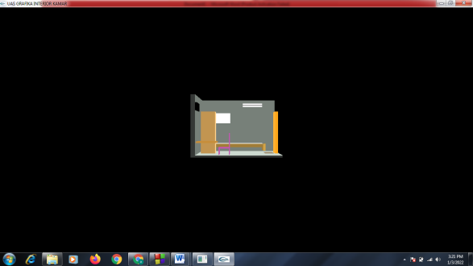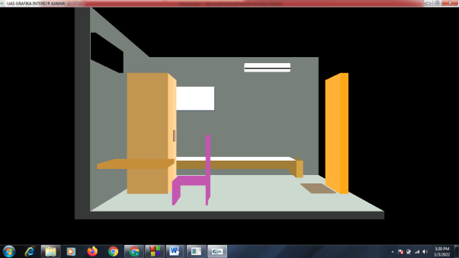

Jika kita menekan tombol “s” maka akan meng-zoom out

Tampilan Awal

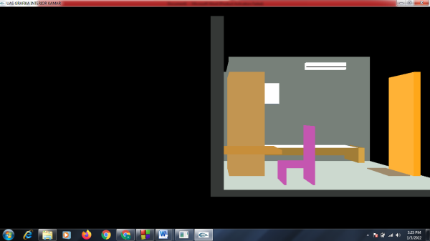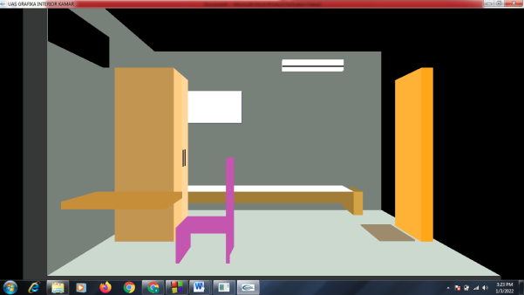

Jika kita menekan tombol “a” maka akan menggeser seblah kanan

Jika kita menekan tombol “w” maka akan meng-zoom in

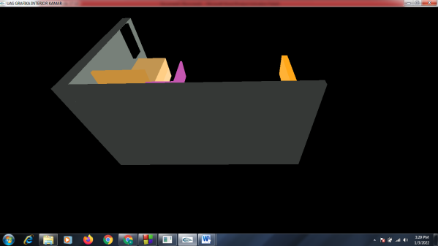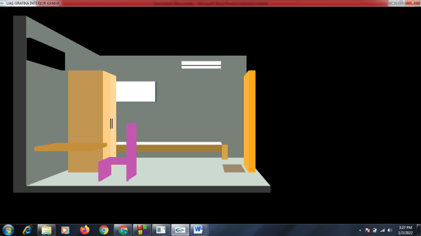

Jika kita menekan tombol “j” maka akan rotate up

Jika kita menekan tombol “d” maka akan menggeser ke kiri

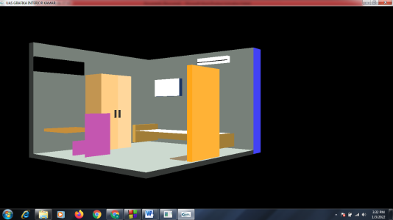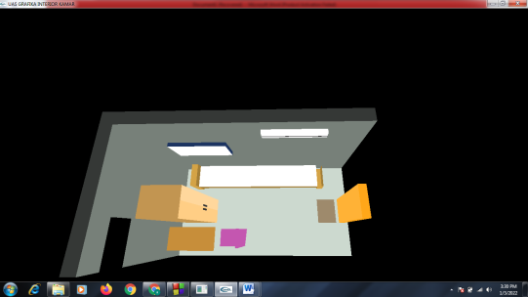

Jika kita menekan tombol “u” maka akan rotate down

Jika kita menekan tombol “r” maka akan rotate right

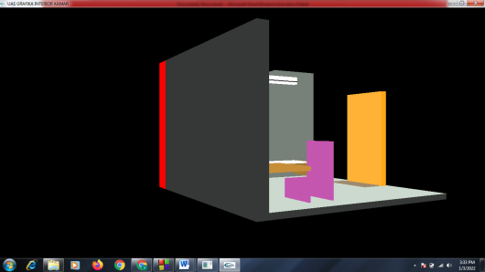

Jika kita menekan tombol “l” maka akan rotate left

Nama : Agung Gumilang

NIM : 200602034

Kelas Informatika Pagi